Python Programming

Experiment Report

Name DIO STANIA ADINATA
Student Number
Major Software Engineering
Class 2023

2022

Experiment 1

Experimental Purpose
Experiment 1 aims to familiarize the student with python by completing list of objectives:
  - Master the installation of the Python interpreter on my computer
  - Familiarize myself with the Python development environment (IDLE) through practice.
  - Master the "print" functionality in Python.
  - Understand the usage of IDLE for Python development in both Interactive and Script modes.
- Experiment Content
  - Objective1: Installing Python
    - Design thought
I plan to download the latest python version that can be download from the official website, the latest version of python is python version 3.14.3. After the installation completed, I will verify the installation by checking the version number by using Command Prompt on windows.

Source Code
On Command Prompt, use python --version to check the python version installed in windows

Experiment Result

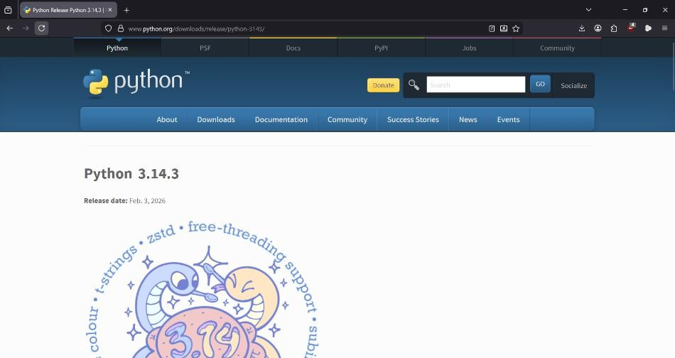
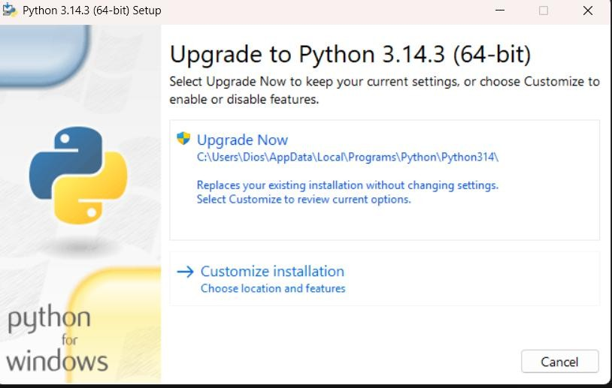
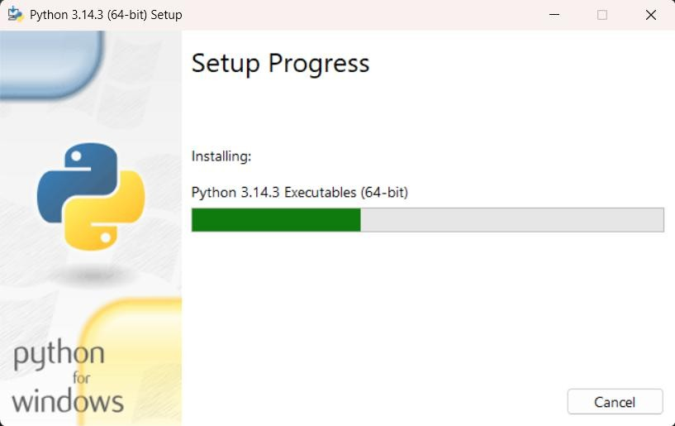

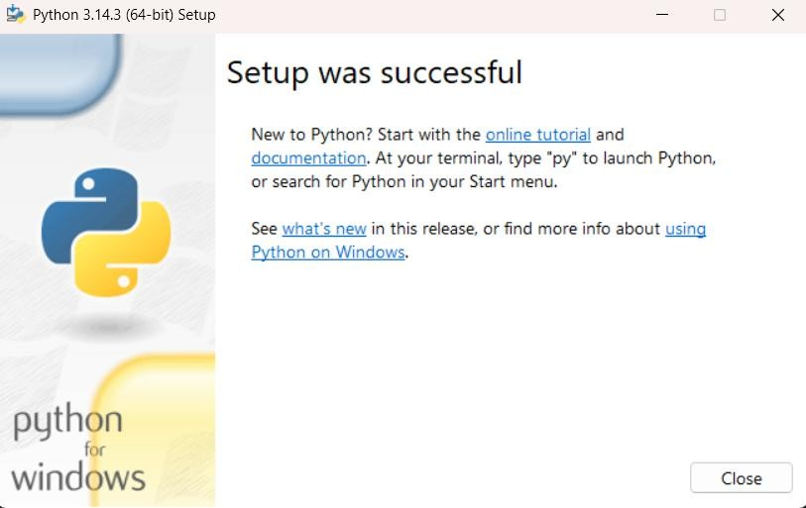
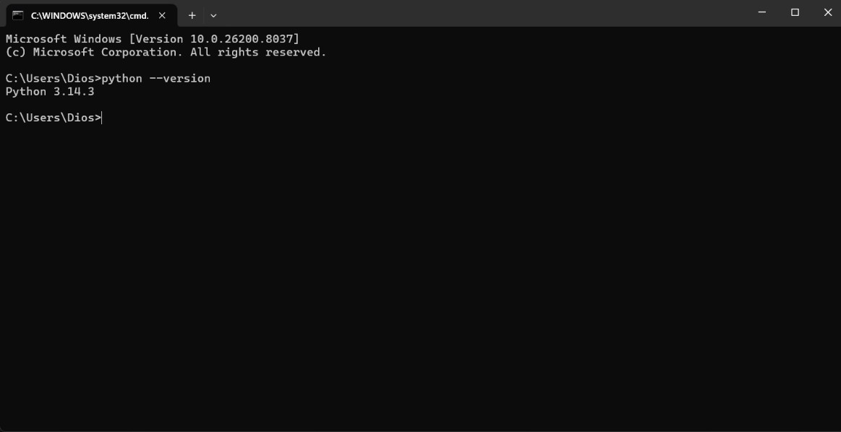
  - Objective2: Install a Third-party Library

Design thought
I plan to install the requests library using the pip package manager using the Command Prompt on Windows. After installation, I will write a Python script in python IDLE Shell to import the library and print its version to validate that it was installed successfully on my computer.

Source Code
import requests print("Installation Successful!")
print("Requests version:", requests. version )

Experiment Result
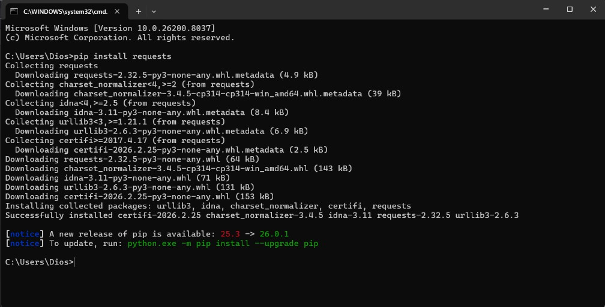

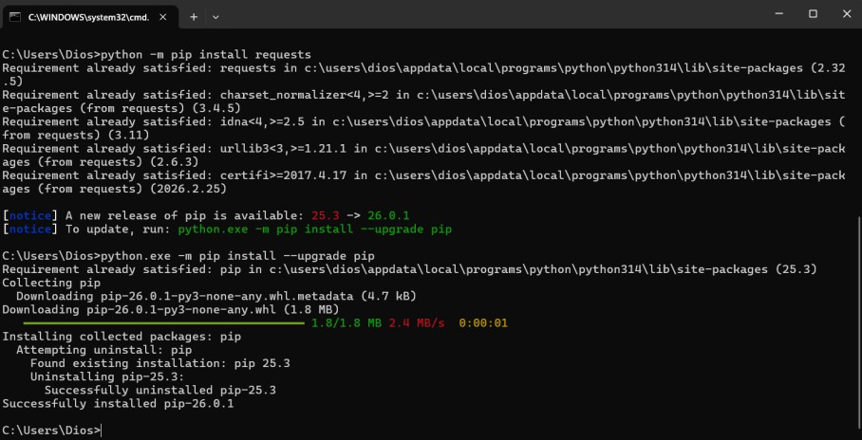
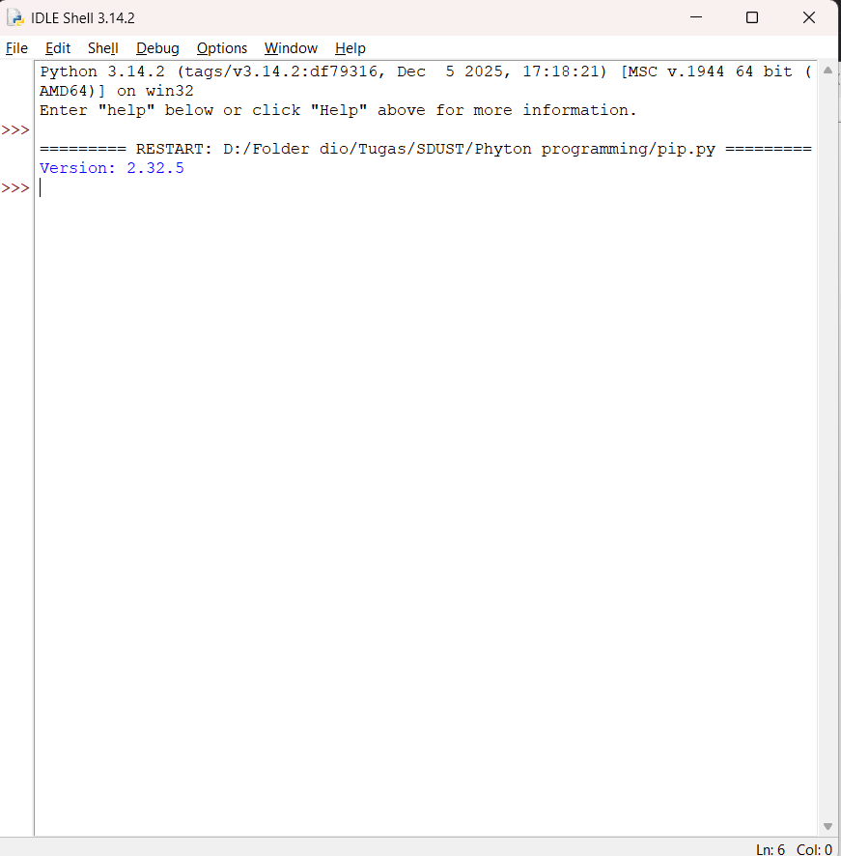

Objective3: Interactive Mode Practice
    - Design thought
I use the Python IDLE Shell (Interactive Mode) to execute a simple print statement directly, Python IDLE Shell is a built-in editor and environment that comes with the python programming language.

Source Code
print("5223600024")

Experiment Result
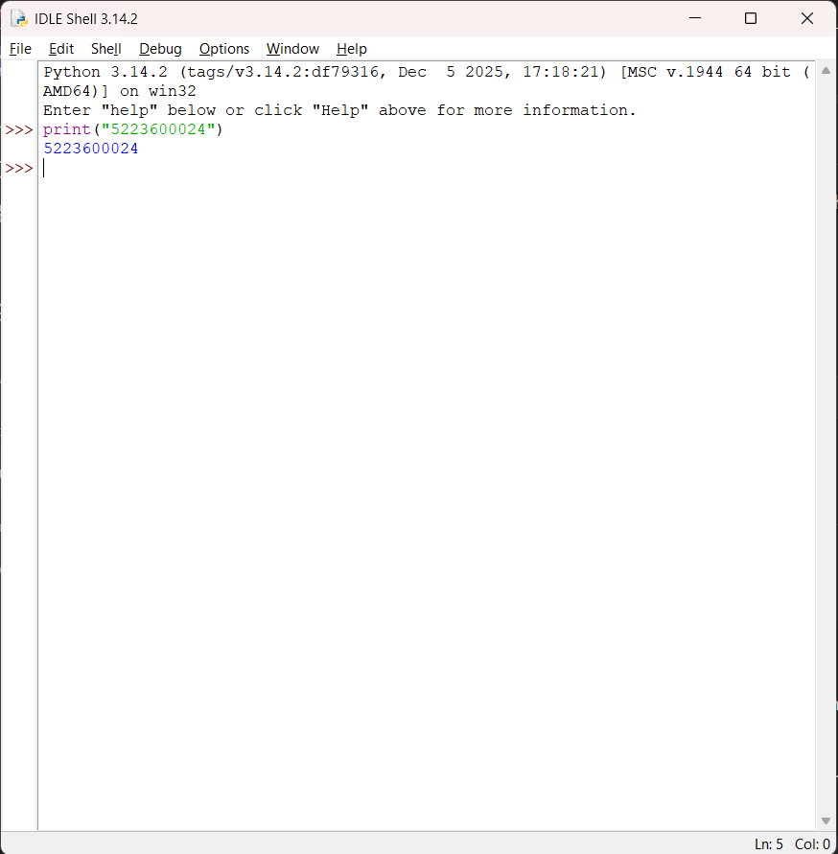

Objective4: Script Mode Practice
    - Design thought
I create a new .py file in IDLE to enable the Script Mode. I write a program that prints both my Student ID and Major simultaneously, after that I will save the file, and run it to verify the output. The script mode in IDLE run a full program from a file, while the interactive mode run one command at a time

Source Code
print("5223600024")

print("Software Engineering")

Experiment Result
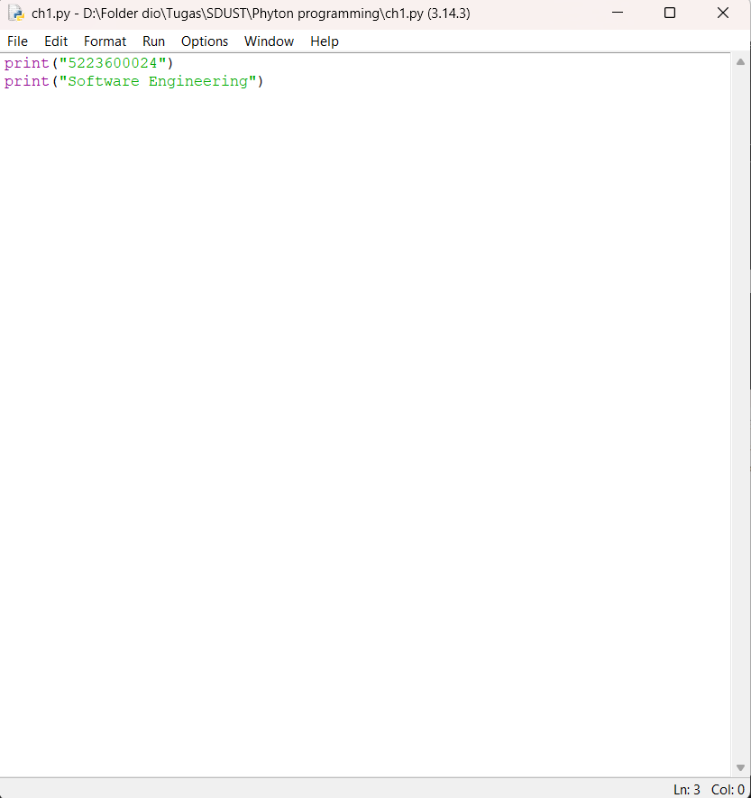
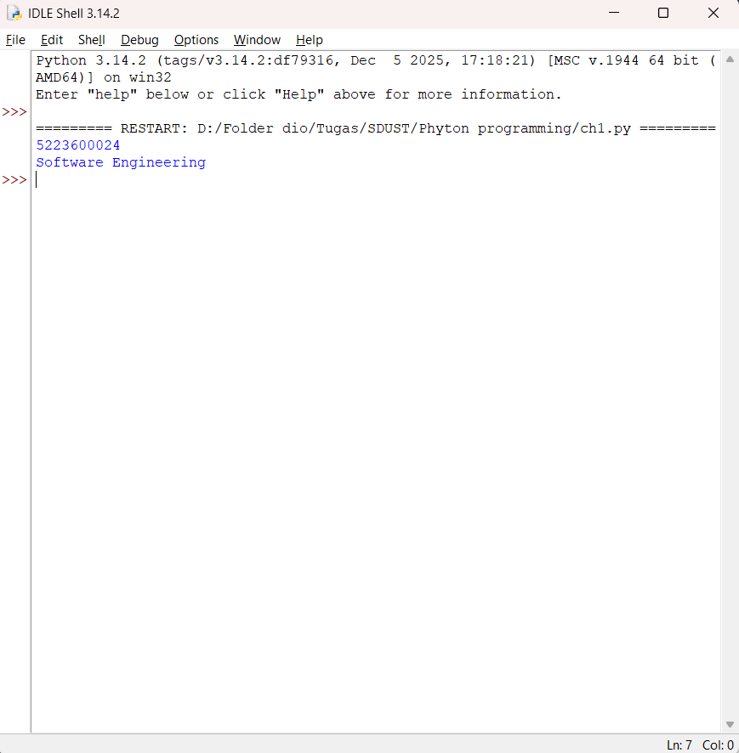

Experiment Conclusion
What did you learn from the experiment?
From this experiment, I learn on how to install the Python interpreter and configured the environment variables. I learned how to use pip to manage third-party libraries and validated the installation programmatically. I also learn about IDLE and how to use it properly, I learn the difference between Interactive Mode and Script Mode. In conclusion, I mastered the basic print() function and how to use python.

